Website feedback/suggestions:
Overview (detail below)
1 | Reorder the four metric blocks below the hero so they read as a timeline (10 min → 3 hrs → 48 hrs → 7 days).
2 | Reword “Three conversations. One exceptional hire.” — readers may think Kit will only speak to three people.
3 | Add a value-add deliverable: a bespoke list of suggested interview questions tailored to the role.
4 | Replace the static chat illustration with a mock shortlist screenshot (the dotted/scored view).
5 | Move candidate-voice testimonials to the For Jobseekers page; replace with hiring-manager quotes here.
6 | Footer: clarify which of the two contact emails (hello@ vs @speaktokit.com) does what.
7 | How Kit Works: strip every em-dash from the page (and ideally the whole site).
8 | How Kit Works: add a short product video in the empty right-hand space next to the hero.
9 | How Kit Works: add a shortlist visual on this page too — same reason as homepage.
10 | For Jobseekers: rebuild the hero to match the homepage pattern — “type what job you’re looking for” input, not a static CTA.
11 | For Jobseekers: refocus the page on Network Kit value-adds (team match report, matched live jobs to inbox, explore your network) — not Screener Kit promises like “feedback on your application.”
12 | For Jobseekers: replace the testimonial names — they’re duplicated from the hiring manager page (this gets fixed naturally if priority #5 lands).
13 | Pricing: Scale tier needs a working CTA — the white box is currently empty.
14 | Pricing: discussion point — add a “Speak to a person” path for sales enquiries who don’t want to start with Kit (recommend: Scale-tier CTA + let Kit escalate to a human on request).
15 | From Alex: add a line of social proof immediately under the hero CTA (e.g. “Trusted by founders at [A] and [B]” or live FOMO counter “joined by 200+ in the last 24hrs”).
16 | From Alex: add a 3-step icon row near the top (1. Define your ICP → 2. Kit scans → 3. Get verified leads) — missing visual primer.
17 | From Alex: discussion point — does Kit need a face / avatar? Risk of feeling more like a database than an assistant. Counter-argument: not having one might be our differentiator.

First impressions
Overall: the design lands. It feels inviting, premium and confident. The animated cursor in the hero input is a strong nudge — it makes you want to type. Most of the homepage is working hard. The notes below are targeted issues and improvements only.
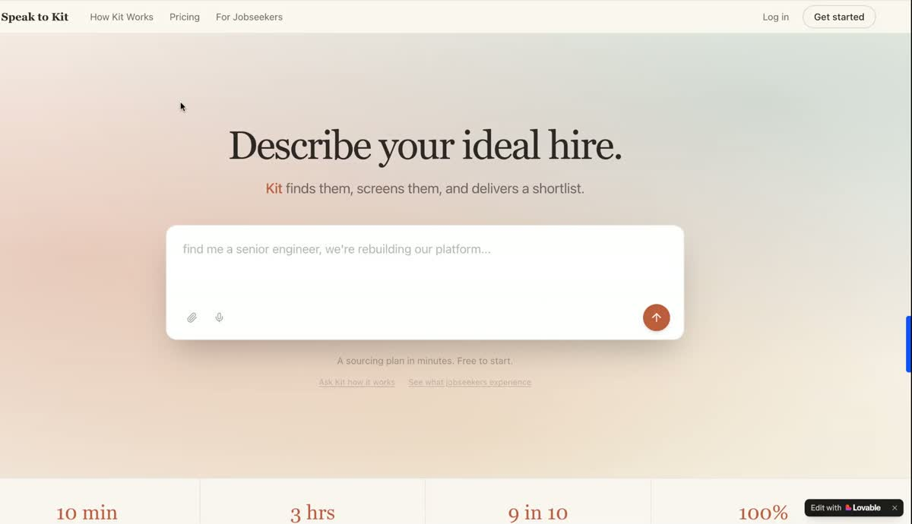
Hero — “Describe your ideal hire.” Strong visual, the typing cursor is a great touch.

1. The four metric blocks should read as a timeline
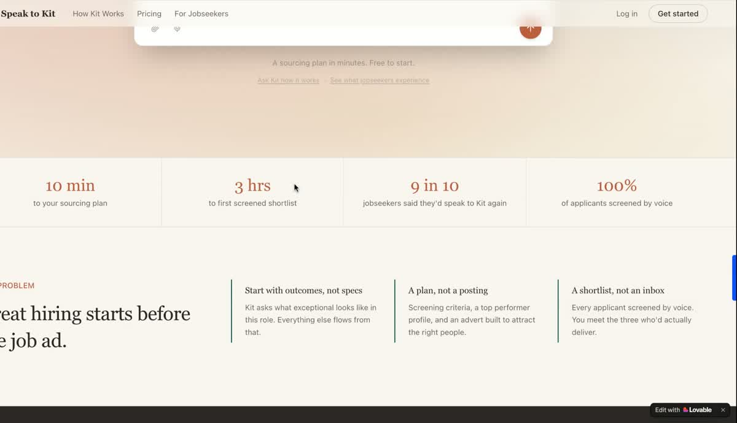
Current: 10 min → 3 hrs → 9 in 10 → 100%. The first two are time-to-outcome, the last two are quality stats. They read as four different things.
ISSUE
The four blocks below the hero mix two different ideas — time-based milestones (10 min, 3 hrs) and quality stats (9 in 10, 100%). The eye expects them to be parallel.
SUGGESTED CHANGE
Make all four blocks a timeline of what someone can expect from the service. Something like:
- 10 min — to your sourcing plan
- 3 hrs — to your first screened shortlist
- 48 hrs — to your first scheduled interview
- 7 days — to your hire
The 9-in-10 and 100% stats are still useful — could re-use them further down the page where social proof / outcomes live.

2. “Three conversations. One exceptional hire.” Could be misread
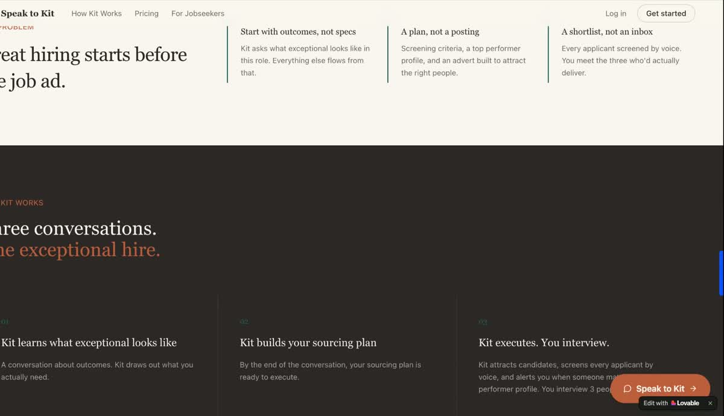
“How Kit works — Three conversations. One exceptional hire.” Sitting directly under “How Kit works”, it reads as if Kit will only ever speak to three people total.
ISSUE
Because this headline sits directly under “How Kit works”, it implies Kit itself will only have three conversations. The intended meaning — that the buyer ends up doing three interviews — gets lost.
SUGGESTED CHANGE
Reframe so it’s clearly about what the hiring manager experiences, not a limit on Kit. For example:
How Kit works — Kit advertises and screens every single candidate for you. Our (users/customers/clients) — (what are we doing to call them?) hold an average of three scheduled interviews for every exceptional hire.
Or simpler: “Three interviews. One exceptional hire.” with a one-liner above clarifying Kit handles everything before the interview.

3. “The Problem” section — keep as is
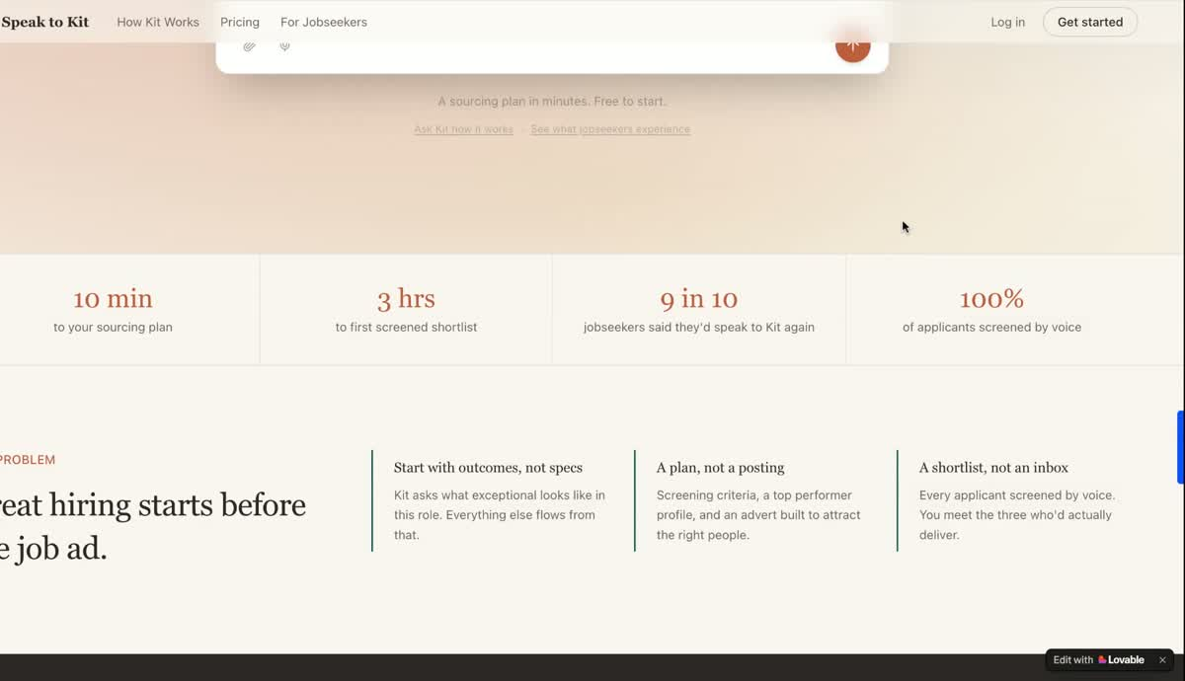
“Great hiring starts before the job ad” + the three sub-points (“Start with outcomes, not specs”, “A plan, not a posting”, “A shortlist, not an inbox”) all land well. No change needed.

4. Add suggested interview questions as a deliverable
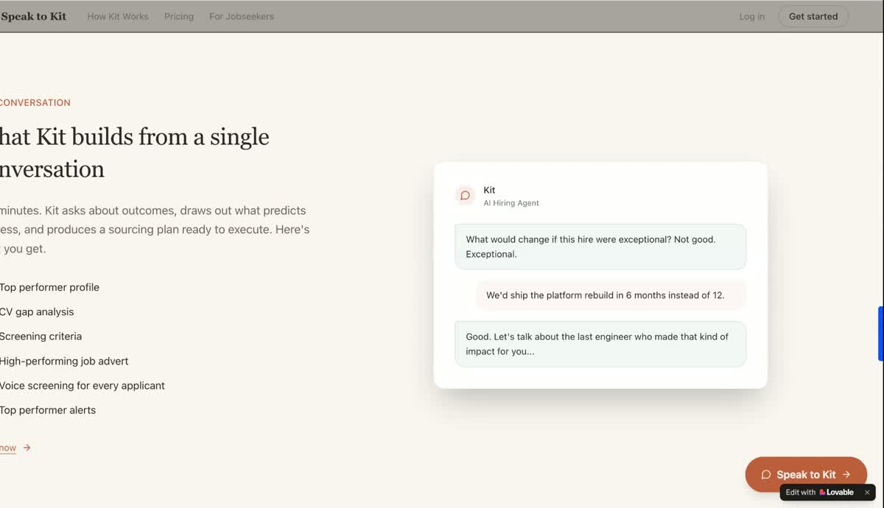
“What Kit builds from a single conversation” — current deliverables list (top performer profile, CV gap analysis, screening criteria, advert, voice screening, top performer alerts).
OPPORTUNITY
A genuine value-add to include in this list: a bespoke set of suggested interview questions, designed specifically against the skills and criteria the hiring manager said they need. It maps directly to “help you make the best decision” and reinforces that Kit is doing the thinking, not just the admin.
SUGGESTED ADDITION TO THE DELIVERABLES LIST
Bespoke interview questions — designed to test the exact skills and traits you said matter for this hire.

5. Replace the chat illustration with a mock shortlist screenshot
ISSUE
The current chat-bubble illustration is nice, and I like it, but it shows the conversation, which is already implied by the section. The shortlist (with the dots and scores per candidate) is a much more powerful visual because it shows the actual outcome the buyer is paying for.
SUGGESTED CHANGE
Swap (or add) a mock shortlist screenshot — the version with the candidate dots/scores. Buyers will instantly understand what they get back. The chat image can move to a secondary spot or to the “How Kit works” section.

6. Testimonials are from the wrong audience for the hiring manager page (and then duplicated on the candidate page)
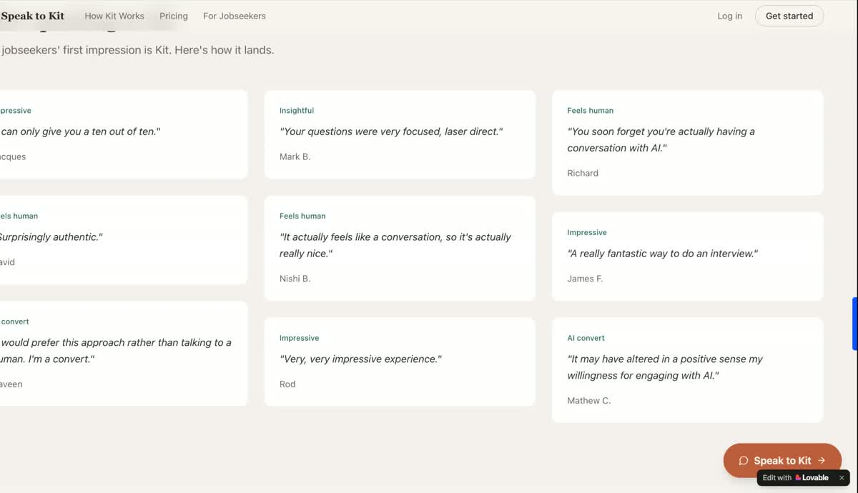
“After speaking to Kit” — current testimonials are candidate quotes (“Surprisingly authentic”, “I’m a convert”, etc.).
ISSUE
This page is targeted at hiring managers, but the testimonials are all candidate voices. It’s not fully jarring — a casual reader sees “people like it” and moves on — but maybe a missed opportunity to reinforce credibility with the actual buyer.
SUGGESTED CHANGE
- Move these candidate quotes to the For Jobseekers page, where they will do real work convincing candidates to engage with Kit.
- Replace this section with hiring-manager quotes. Examples of the tone we want:
“Kit understood my job in five minutes.”
“I had three interviews booked within a week.”
“It felt like Kit knew me and my team within 30 seconds.”

7. Footer — clarify the two email addresses
ISSUE
The footer shows two contact emails (hello@speaktokit.com and another @speaktokit.com address). It’s unclear which is for what.
SUGGESTED CHANGE
Either drop to a single email, or label each one explicitly (e.g. “hello@ — general enquiries”, “support@ — existing clients”). Small thing, but removes a moment of friction.
Side note: the orange logo treatment in the footer works really well — keep.

Page feedback: How Kit Works
Quick pass on the How Kit Works page. Mostly working — the headline and the structure of the conversation section are doing the job. Three concrete changes below.

1. Hero headline — keep
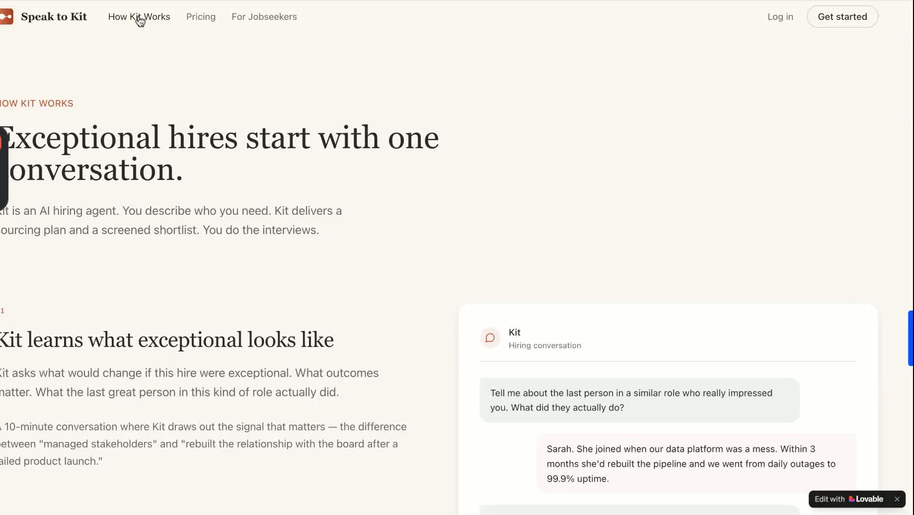
“How Kit Works — Exceptional hires start with one conversation.” Lands well, ties directly to the homepage promise.
VERDICT
“Exceptional hires start with one conversation” works. It carries the same brand voice as the homepage and sets the right expectation before the user starts scrolling. Keep.

2. “Kit learns what exceptional looks like” — strong section
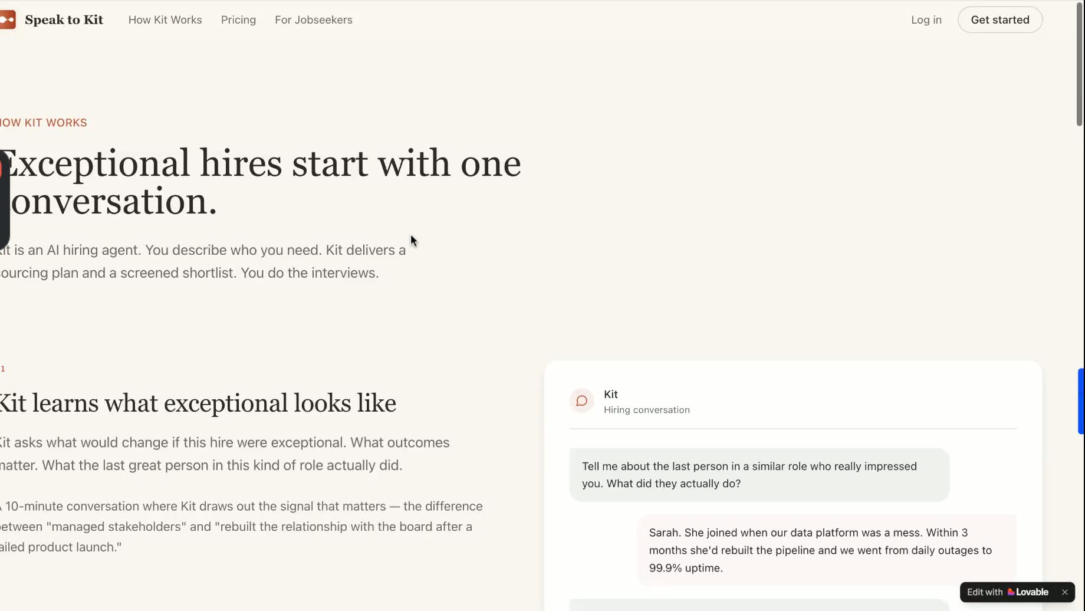
The chat mock with “managed stakeholders” / “rebuilt the relationship with the board” is exactly the level of signal that earns trust.
VERDICT
This is the strongest part of the page. The example messages — the difference between “managed stakeholders” and “rebuilt the relationship with the board” — prove Kit is asking real questions, not just collecting form fields. Keep as is.

3. Strip every em-dash from this page (and the whole site)
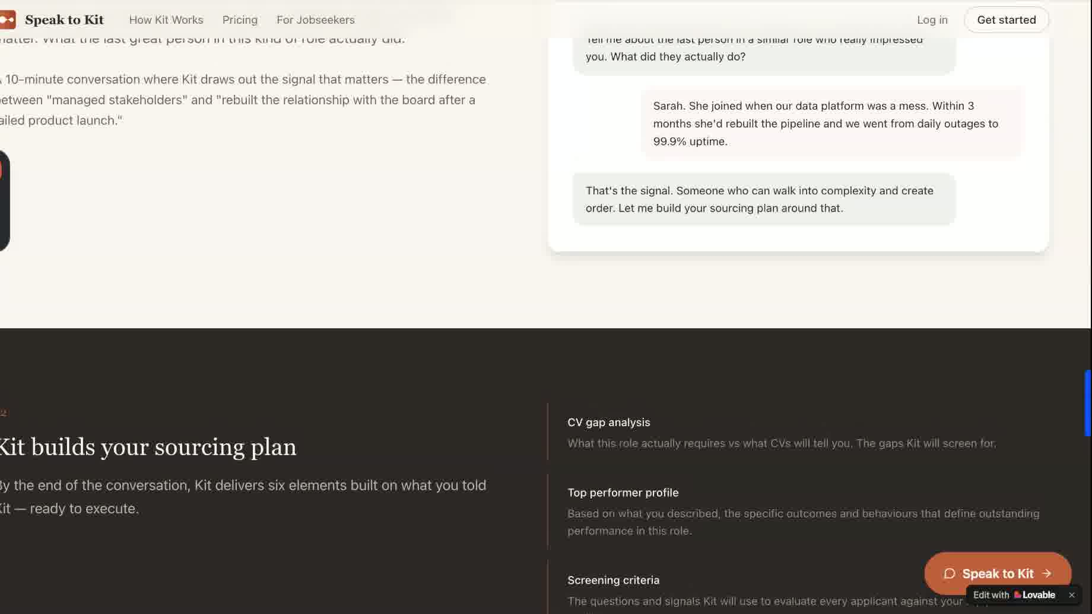
Example: “A 10-minute conversation where Kit draws out the signal that matters — the difference between ‘managed stakeholders’ and ‘rebuilt the relationship with the board after a failed product launch.’”
ISSUE
Em-dashes (—) read as AI-written copy now. They’re scattered across this page and most likely the rest of the site. Even if a human wrote them, it lowers the perceived effort.
SUGGESTED CHANGE
- Do a site-wide find-and-replace on — (em-dash) and – (en-dash).
- Replace with: a comma, a full stop, brackets, or split into two sentences — whichever reads more naturally for that line.
- Example rewrite of the line above:
“A 10-minute conversation where Kit draws out the signal that matters. The difference between ‘managed stakeholders’ and ‘rebuilt the relationship with the board after a failed product launch.’”

4. Add a product video in the empty right-hand space
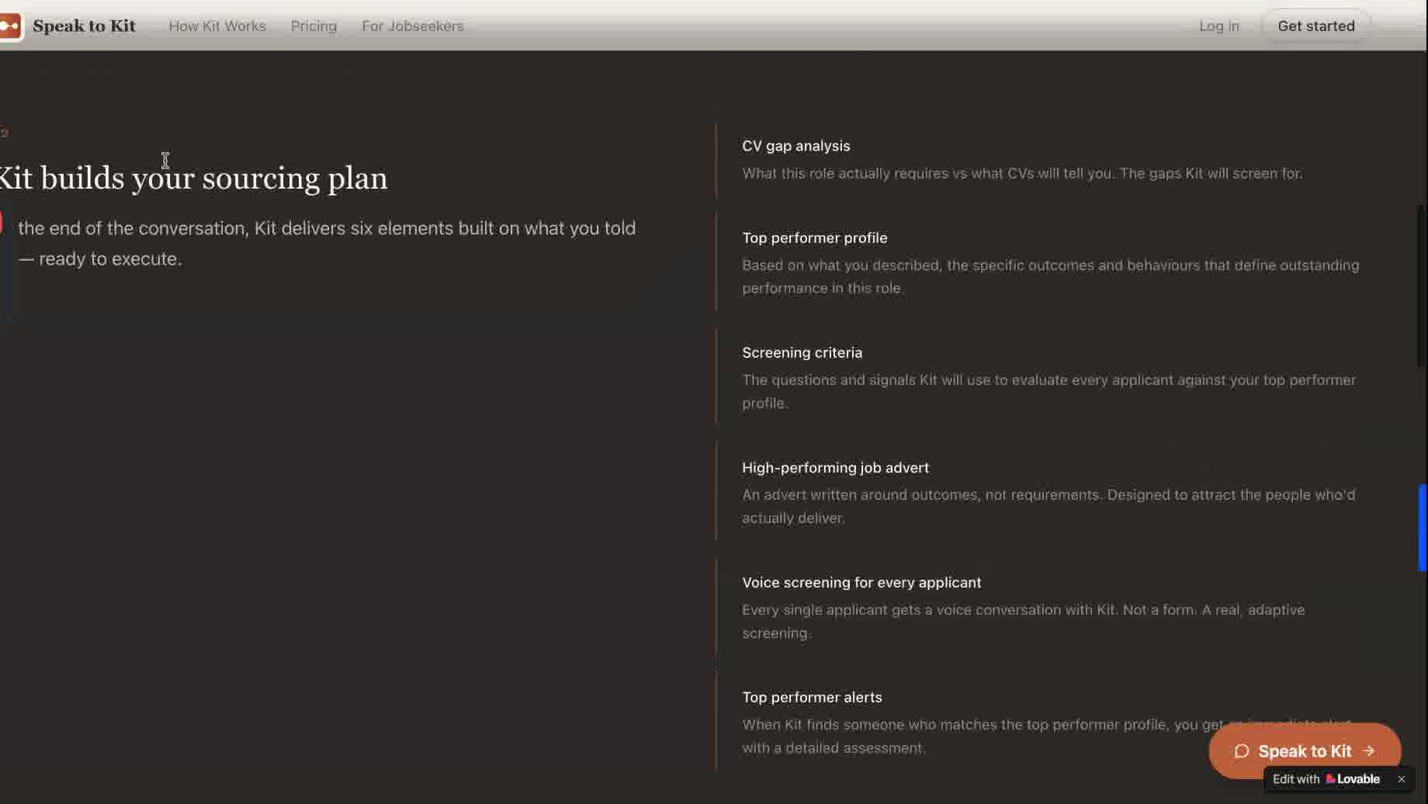
Below the hero, the right-hand column is empty until the chat mock kicks in. Prime real estate.
OPPORTUNITY
There’s a big empty area to the right of the hero copy. A short looping video (30–60 sec, no sound) of Kit in action — someone speaking to Kit, Kit responding, a shortlist appearing — would do more work than any extra copy could.
SUGGESTED CHANGE
- Drop a short autoplay/muted/looping video into that right-hand area.
- Best option: a screen recording of an actual Kit conversation, sped up, ending on the shortlist.
- Second-best: a Loom-style talking head from you walking through one real example.

5. Add a shortlist visual on this page too
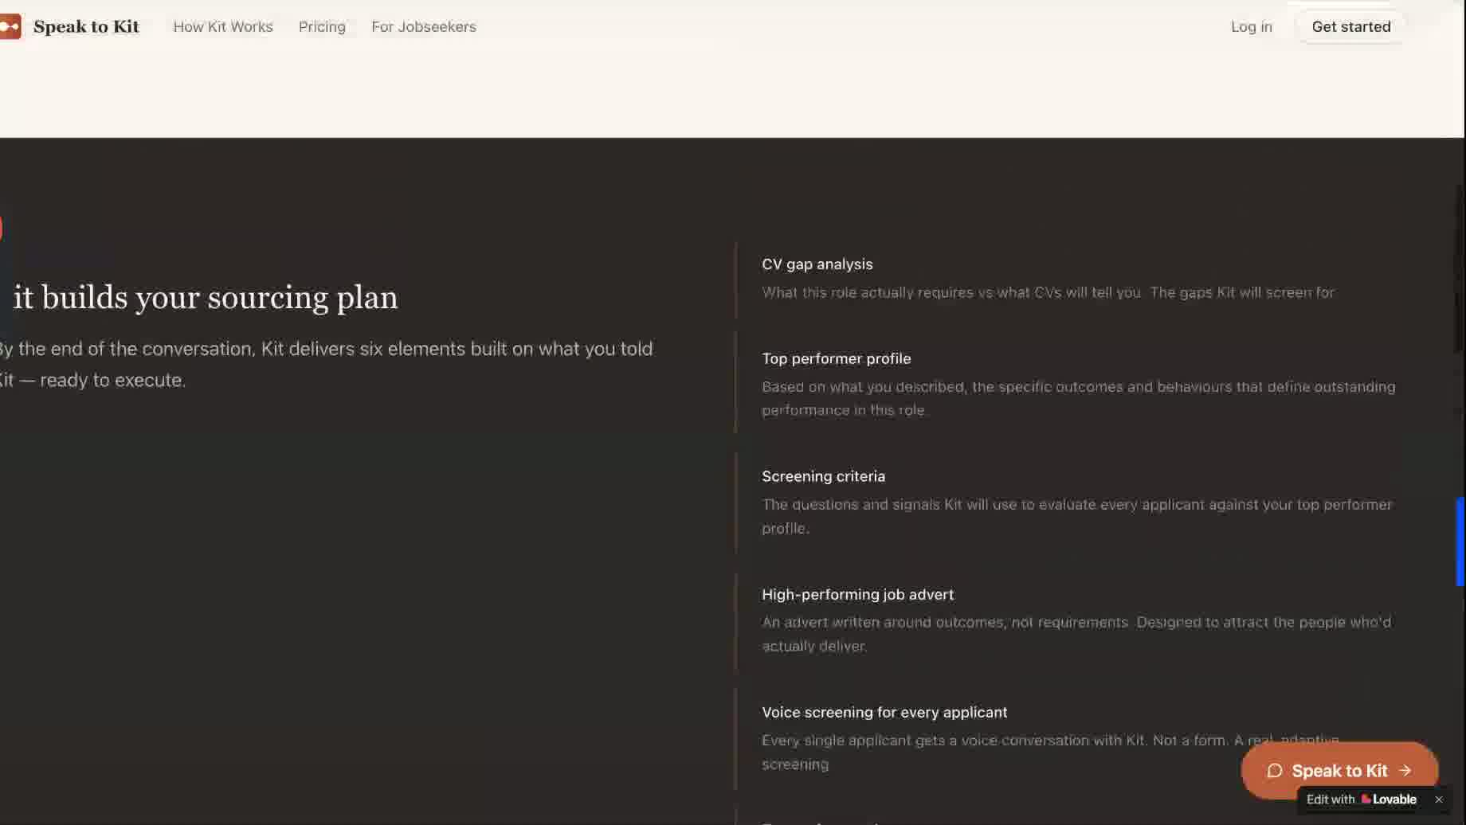
“Kit builds your sourcing plan” — the six deliverables are listed, but never shown.
ISSUE
The deliverables section lists six things Kit produces, but never shows what any of them actually look like. Same problem as the homepage — buyers can read a list, but they can’t picture the output.
SUGGESTED CHANGE
Add a mock of the shortlist (the dotted/scored candidate view) on this page, ideally next to or directly under the deliverables list. Bonus: also mock a screenshot of the “Top performer profile” or the “CV gap analysis” — even one would change this section from a promise to a preview.
If you can only do one image — do the shortlist. It’s the moment of value.

Page feedback: For Jobseekers
This page is the weakest of the three. Big idea: it’s currently a mash-up of Network Kit and Screener Kit value props, and it’s missing the input pattern that makes the homepage hero work. Three things to fix.

1. Make the hero match the homepage pattern
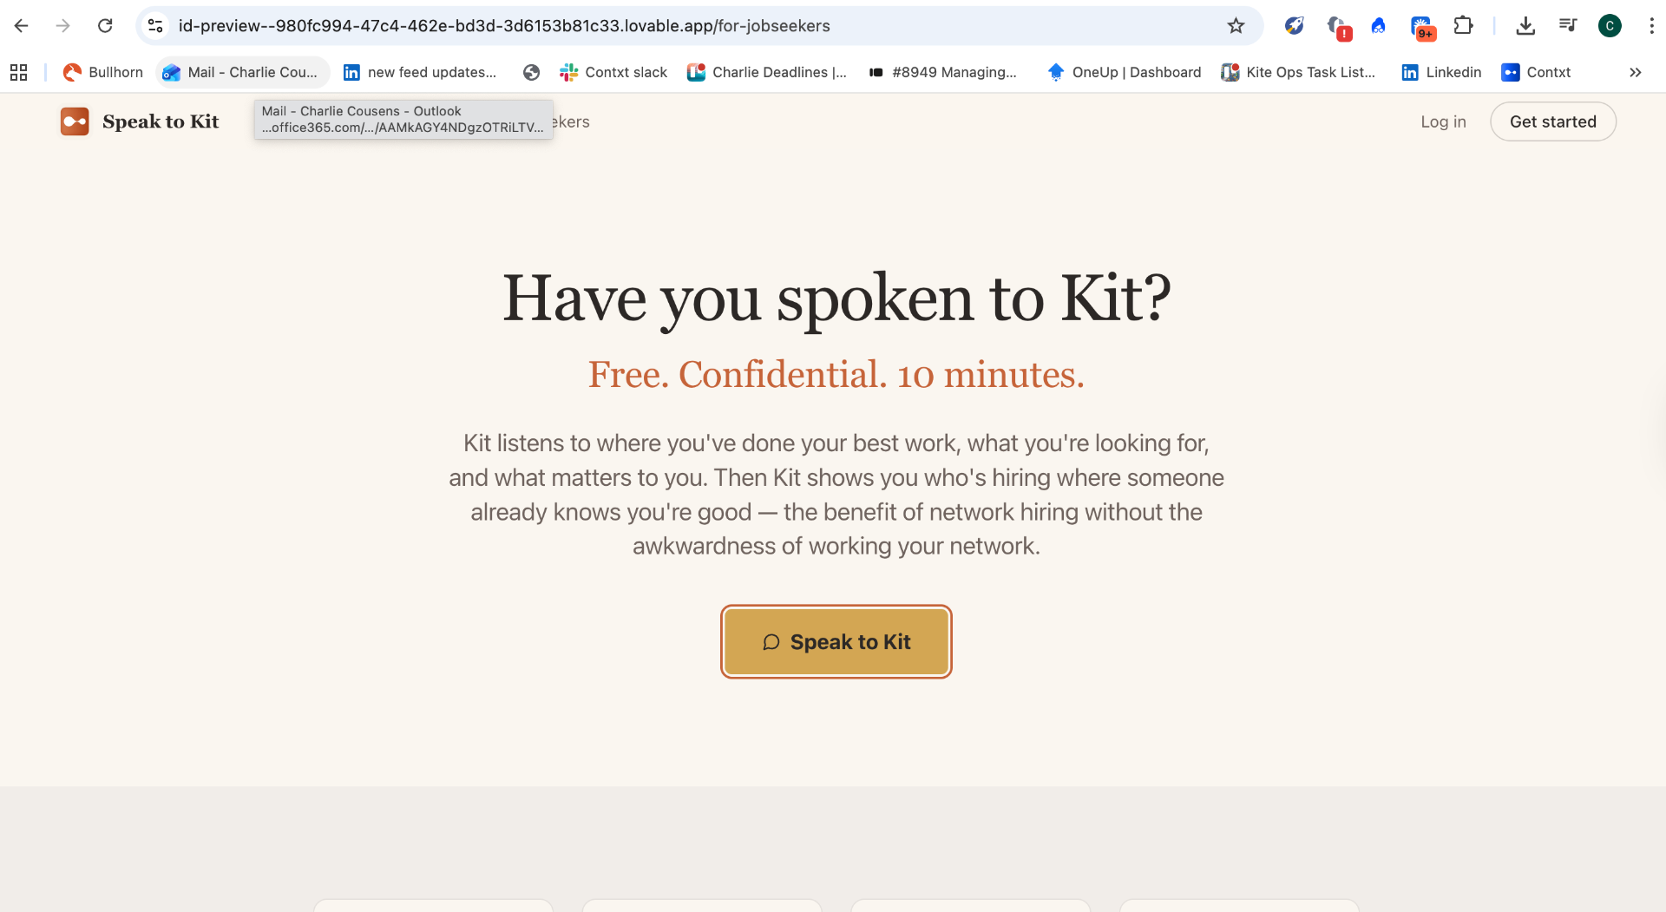
Current jobseekers hero: “Have you spoken to Kit?” + “Speak to Kit” button. Static, generic, no input.
ISSUE
The homepage hero works because it invites you to type — “Describe your ideal hire” with the animated cursor pulls you in. This page just has a button. We’re asking jobseekers to take a leap of faith with no preview of what the conversation will be about.
SUGGESTED CHANGE
Mirror the homepage pattern exactly: an input field with a typing cursor, but framed for the candidate. Something like:
“Type the job you’re looking for…”
“Tell Kit what you do best…”
Same animation, same energy. The user starts typing and is immediately in conversation with Kit — no “click a button and hope” moment.

2. Refocus the page on Network Kit value-adds
ISSUE
Right now the page mixes things Network Kit can deliver (a candidate visiting the site cold) with things only Screener Kit can deliver (someone funnelled in against a specific job). “Feedback on your application” is the obvious one — a candidate who walks in off the homepage isn’t applying to anything yet, so we can’t promise that.
SUGGESTED CHANGE
Strip out the Screener Kit value-adds from this page. Replace them with what Network Kit actually does for a cold candidate:
- Team match report — a snapshot of where your skills, style and outcomes fit.
- Matched live jobs sent to your inbox — only the roles that genuinely fit, not a daily firehose.
- Explore your network — see where someone already knows your work (without giving the whole game away).

3. Testimonials — fix the duplication
ISSUE
The quotes on this page use the same names as the ones on the hiring manager page. Anyone who clicks between the two will spot it immediately, and it kills the credibility of both sets.
SUGGESTED CHANGE
This one largely fixes itself if priority #5 lands (move candidate quotes off the homepage and onto this page — with their real candidate names). But worth flagging explicitly: every testimonial on the site needs a unique name + face, and they need to be on the right page for the right audience.
- Homepage: hiring manager quotes only.
- For Jobseekers: candidate quotes only.
- No name should appear on both pages.

Page feedback: Pricing
Overall: the pricing page is in great shape. The four-tier structure is clear, the “Popular” flag on £99 does its job, and the value ladder (network matches → screening calls → outreach) makes intuitive sense. One small fix and one bigger discussion point below.
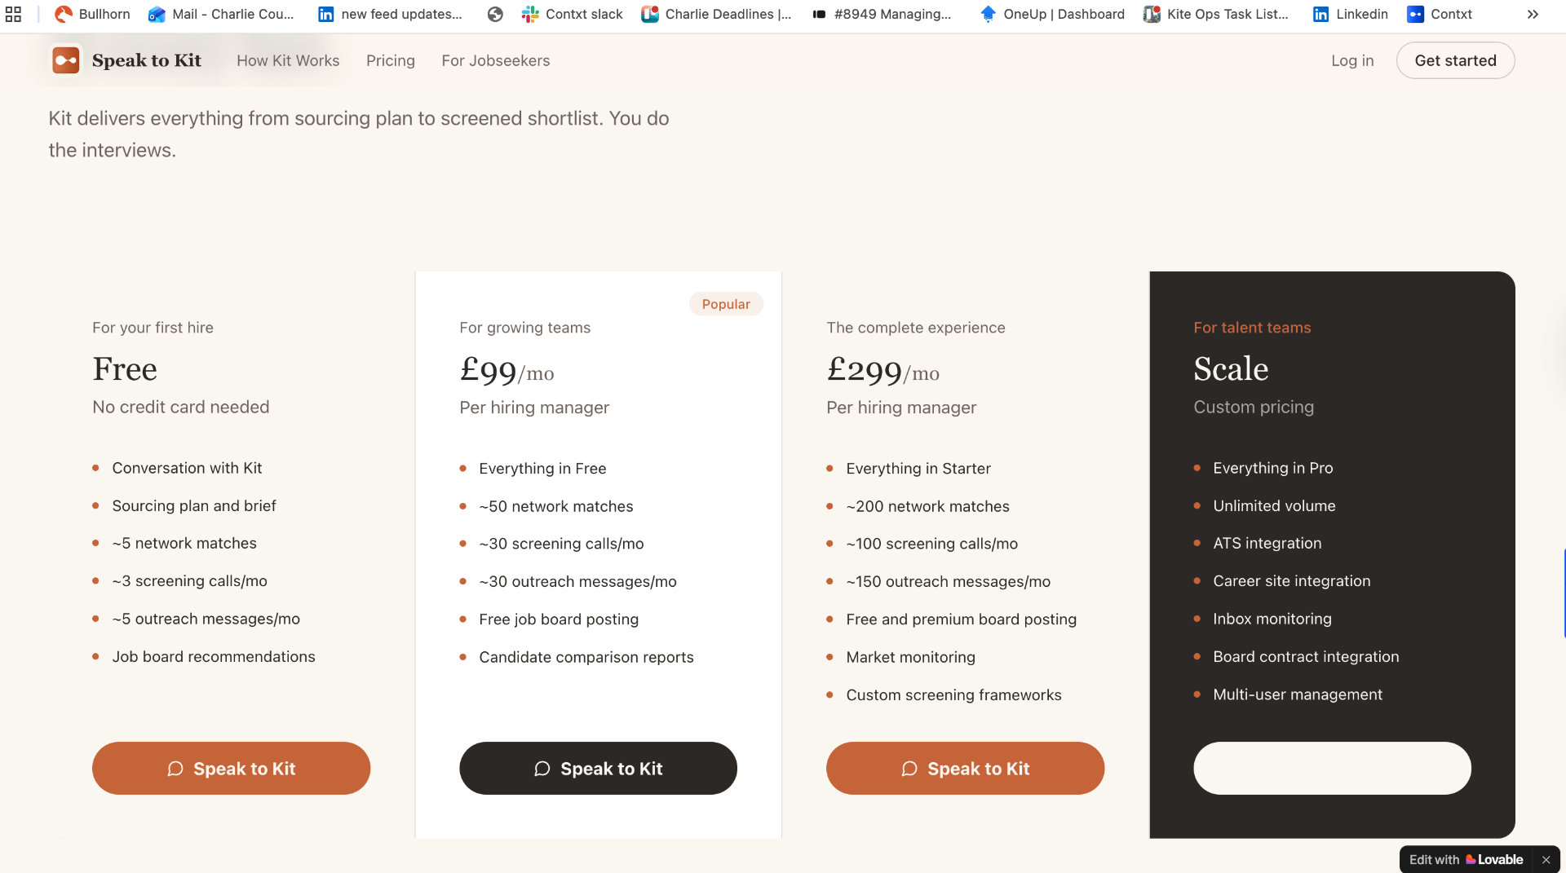
Current pricing page: Free / £99 / £299 / Scale. Three tiers with “Speak to Kit” CTAs, Scale tier has an empty white CTA box.

1. Scale tier — the CTA box is empty
ISSUE
The Scale card has an empty white pill where the CTA should be. Every other tier has a clear “Speak to Kit” button — Scale just has… nothing. Anyone landing here from an enterprise context hits a dead end at the moment of highest intent.
SUGGESTED CHANGE
Fill the CTA. What it says depends on the answer to the next discussion point, but at a minimum it shouldn’t be blank. Default option:
“Talk to our team” — opens an email to hello@ or a Calendly link.

2. Discussion point: do we add a “Speak to a person” path?
THE QUESTION
Should we add a “Speak to a person” button somewhere on this page — in case a sales enquiry doesn’t want to talk to Kit, or has a bespoke idea they want to discuss with a human?
ARGUMENTS FOR
- High-intent buyers (enterprise, bespoke deals, procurement) often won’t self-serve through an AI, no matter how good Kit is. We lose them silently.
- The Scale tier already says “Custom pricing” — that implies a human conversation but doesn’t offer one (see point #1).
- Removes a small but real anxiety: “what if my situation is weird?”
ARGUMENTS AGAINST
- The whole product premise is “Speak to Kit.” A “Speak to a person” button on the pricing page subtly undermines that — it says even we don’t fully trust Kit for the important conversation.
- It can become a crutch — sales enquiries default to the human path and Kit never gets stress-tested on real buyers.
THREE OPTIONS WORTH FLOATING
- Option A: Only on the Scale card. Replace the empty white CTA with “Talk to our team.” Keeps Kit as the default everywhere else, gives enterprise the human path they expect.
- Option B: Small text link below the grid. “Got a bespoke question? [email or book a call].” Low-key, doesn’t compete with the Kit CTAs.
- Option C: Let Kit handle it. Give Kit a “I’d like to speak to a human” intent. Most modern AI-first companies do this. Keeps the brand promise intact and we still capture the lead.
MY RECOMMENDATION
Option A + Option C. Human button only on the Scale tier (where buyers expect it anyway), and Kit itself can escalate to a person on request. That way the homepage promise stays clean and we don’t lose enterprise enquiries.
“Speak to Kit” everywhere except Scale. Scale gets “Talk to our team.” And Kit knows how to fetch a human if asked.

Additional feedback: Alex
Captured below from Alex’s review of the site. Mostly homepage-focused, with a couple of bigger strategic questions worth a team discussion.

Overall impression
Visually it’s clean and modern. Feels quite Apple-esque and portrays trust and authority.
Hook is excellent: “Tell Kit who you need. Kit finds them.”
CTA is prominent.

1. Add a line of social proof under the hero CTA
SUGGESTION
Should we consider adding a small line of social proof immediately under the CTA?
- “Trusted by founders at [Company A] and [Company B]”
- “5,000+ leads found this month”
- “Joined by 200+ people in the last 24hrs” — to create FOMO and drive virality
Either approach (logos vs. live counter) works — worth A/B testing once we have the volume.

2. Add a 3-step icon row near the top
MISSING ELEMENT
A small 3-step icon row would orient the visitor in two seconds. Something like:
1. Define your ICP → 2. Kit scans → 3. Get verified leads
Sits between the hero and the longer explainer sections — a visual primer for people who skim before they read.

3. Discussion point: does Kit need a face / avatar?
THE QUESTION
I’m sure this has been discussed before, but does Kit need a face or avatar? Without some sort of persona, does Kit feel less like an assistant and more like a database?
COUNTER-ARGUMENT
That said, our competitors all do it that way — so maybe the distinction is a good thing. Faceless could read as “more tool, less gimmick,” which fits the Apple-esque trust-and-authority positioning.
WORTH DEBATING
- If we add a face: avoid the generic friendly-robot trope. Something abstract (a mark, a waveform) might thread the needle.
- If we don’t: lean harder into the typography and the conversational copy as Kit’s personality.

